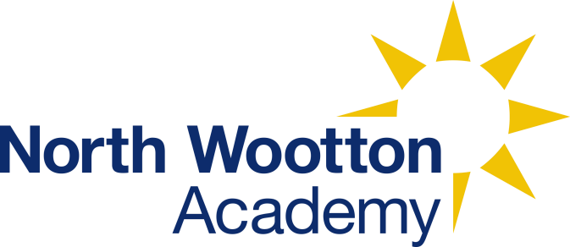 | North Wootton Academy  Priory Lane  North Wootton  Kings Lynn  Norfolk  PE30 3PT
Name of policy: | Geography Policy
Lead member of staff with responsibility for this policy:
Date of implementation: | 6th September 2024
Details of dissemination: | The policy is available for all staff, visitors, pupils and parents on the school website.
Linked Policies: | Most curriculum policies  Curriculum Policy
Frequency for review: | Annually

In Geography, the children know that:

Geography is where we explore the places and atmosphere around us and the relationship between people and our environments.

Today we are being geographers: We use globes, maps and atlases as tools to investigate Earth and the distribution of its land, features and inhabitants.

Intent
At North Wootton Academy we believe Geography is an important part of the curriculum that engages children’s minds to wonder and investigate the world around them. We intend for our pupils to be local and global learners who have a strong understanding of UK, European and the International world. We encourage them to be open-minded about the world on their doorstep as well as the far-reaching corners through sharing an appreciation for cultural diversity.

This document outlines the expectations of our Geography curriculum and can be used alongside the Geography curriculum overview to inform planning, teaching and assessment.

Geographical Pedagogy
It is our intention that Geography teaching will encompass active, fun and intriguing lessons where the children can experience first-hand the wonders of our local environment. Where it is not always possible to be out investigating the world, we will aim to provide opportunities that include geographical artefacts and maps to support interest and learning.

Implementation
Our Geography curriculum, underpinned with geographical and environmental knowledge, develops key observational and investigatory skills in our pupils. We use plans provided by the Primary Knowledge Curriculum, although the progression of these many alter due to our mixed classes. We place a high importance on children developing skills in ‘Field Work and Investigation’ as well as ‘Map and Atlas Work’. As children progress through the school years their knowledge builds as does the content for the skills, as shown in the accompanying document Geography Curriculum Overview.

Key skills within Geography at North Wootton Academy include:
Field Work and Investigation
- Observe, measure, record and present the human and physical features of the local area
Map and Atlas Work
- Use a range of methods to record mapping knowledge which locates countries and their features
Knowledge
- Informed knowledge of local and global countries/continents and geographical features and how these physical aspects may change overtime

The skills that we learn through geographic enquiring support us to showcase the knowledge that we have learnt which works towards the end attainment aims from the National Curriculum, as listed below.
- develop contextual knowledge of the location of globally significant places – both terrestrial and marine – including their defining physical and human characteristics and how these provide a geographical context for understanding the actions of processes
- understand the processes that give rise to key physical and human geographical features of the world, how these are interdependent and how they bring about spatial variation and change over time

Geography in Reception
Through our balanced play and formal Reception curriculum we encourage children to discover the immediate environment around them. Our pupils enter Reception knowing a very small part of the world, so through our planned learning opportunities and guided topical learning we endeavour to broaden their initial geographical knowledge and understanding. Reception classes work within the Early Years Foundation Stage curriculum, which sees our youngest pupils access Geography through the ‘Understanding the World’.

Early Learning Goals.
Reception Key Skills
Field Work and Investigation
- Clear and basic knowledge of observing the changing environment
Map and Atlas Work
- Understand the physical map of their local environment and relate self to position and distance
Knowledge
- Basic knowledge of the seasons and weather changes

Impact
Within Geography, we aim to provide investigative learning opportunities to support children in gaining coherent knowledge of understanding of each unit of work covered throughout the school. This is assessed through multiple choice quizzes throughout the unit as well as an end of unit assessment. The assessments should be varied in task, including but not limited to, written pieces, talk tasks, multiple choice questions and interpretating graphs and tables. In addition, the school tracks key skills such as mapping, which are recorded through the use of rubrics.

Internationalism Intermediate Award
At North Wootton Academy we are continuing our journey towards the British Council Foundation Award for Internationalism. Over the coming years we will be working towards the various levels of this award and accreditation. This will support the school and pupils in exploring the world through having links with schools abroad as well as understanding our own heritage and cultural diversity. This will be an involving project as we grow as a school community. As of September 2024, we had achieved the Intermediate Award through out work with the Aquila School in Dubai. We are now seeking new opportunities to build international relations to continue our journey to the full accreditation in the future.

Inclusive
To support all pupils at North Wootton Academy, we have created a progressive framework to measure attainment across the subject and phases. This will take the style of rubrics that support children’s learning through a three step progression of working towards, working at and working beyond. We offer a ‘high ceilings’ approach with adaptation to support all in achieving the same or similar outcomes in line with personal development.

Monitoring and Review
As the Geography Subject Lead updates and changes the subject action plan, this document will too be altered to fit with current school practice.

